# **UNIX ARCHITECTURE**

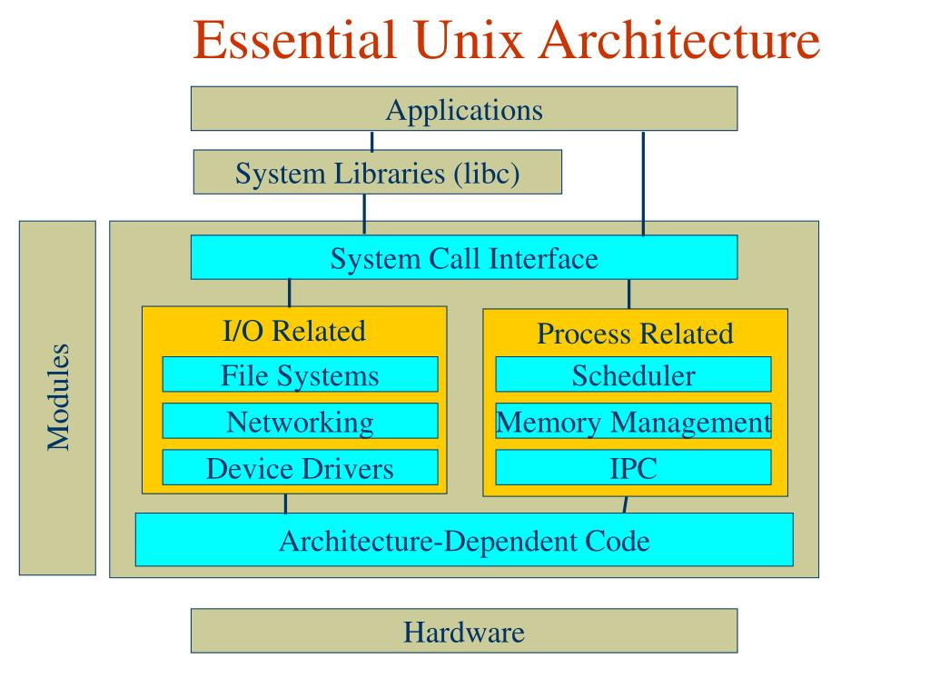

* **Definition:-**

UNIX architecture is centered on a kernel that manages hardware resources and facilitates communication. Its modular design, characterized by small utilities and a command-line interface, enables efficient interaction. With a hierarchical file system and robust networking capabilities, UNIX is known for its versatility and suitability for both single-user and networked environments.

* **Features of UNIX System:-**
  1. **Multiuser and Multitasking:**

UNIX supports multiple users accessing the system concurrently, each with their own processes. Additionally, it enables multitasking, allowing several processes to run simultaneously.

* 1. **Portability:**

UNIX is highly portable, capable of running on various hardware architectures. This portability has contributed to its popularity across different computing platforms.

* 1. **Hierarchical File System:**

UNIX organizes files and directories in a hierarchical structure, simplifying data management. This file system treats devices and network resources as files, providing a unified interface.

* 1. **Command-Line Interface (CLI):**

UNIX relies on a powerful command-line interface (CLI) or shell, allowing users to interact with the system by typing commands. This approach provides flexibility and scripting capabilities.

* 1. **Modularity and Small Utilities:**

UNIX follows a modular design philosophy, employing small, single-purpose utilities that perform specific tasks. These utilities can be combined to create complex workflows and provide a high degree of flexibility.

* 1. **Security Features:**

UNIX incorporates security measures such as user permissions, file ownership, and authentication mechanisms. It follows the principle of "least privilege," restricting access based on user roles.

* 1. **Networking Capabilities:**

UNIX was designed with networking in mind. It supports networking protocols and features, making it well-suited for distributed computing and serving as a foundation for internet technologies.

* 1. **Compatibility and Standards**:

UNIX adheres to open standards, promoting compatibility across different implementations. This adherence to standards enhances interoperability and facilitates the development of compatible software.

* 1. **Shell Scripting:**

Users can automate tasks and create more complex programs by writing scripts in the shell scripting language. This capability simplifies repetitive tasks and enhances efficiency.

* 1. **Continuous Evolution:**

UNIX has demonstrated a remarkable ability to evolve over time. Various Unix-like operating systems, including Linux and BSD, continue to be actively developed and used in diverse computing environments.